Report 1 for Radio Communications

Student: Yan Fei

Tutor: Dr. David Siddle

I declare that this assignment is my own work, that sources of reference are acknowledged and that it has not been submitted for any other course. I understand that plagiarism is a serious offence under the University’s regulations and that appropriate penalties will be applied if I am found to have submitted plagiarism work.

# Part One

## Exercise AR1

### Running raypath.m

raypath(10, 18, 40, 90)

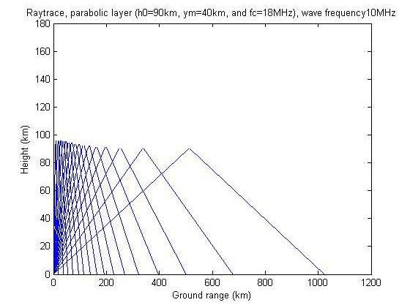

raypath(10, 8, 40, 90)

# C:\Documents and Settings\tony\Desktop\EG7023\2.jpg

For D layer, we can see that when wave frequency is smaller than the critical frequency, there are no penetrating rays. However, when wave frequency is bigger than critical frequency and the ground range is short enough (within skip zone), the rays will penetrate the D layer. Also, we can see that the height of reflection and ray density decrease when the ground range increases in both graphs above.

raypath(10, 8, 40, 105)

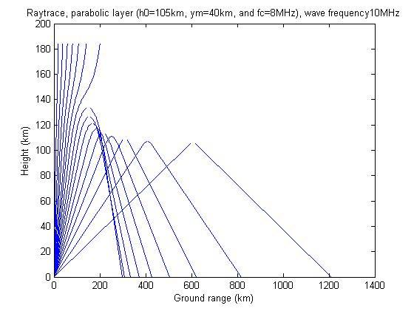

raypath(10, 18, 40, 105)

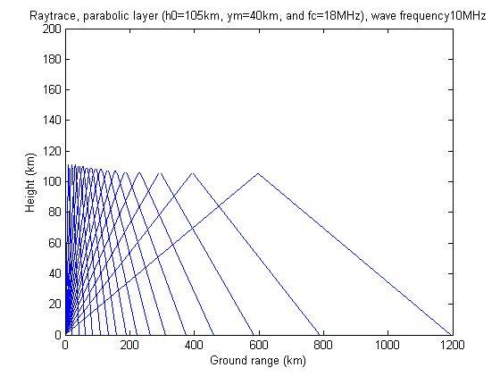

For E layer, the condition is similar as E layer. The difference is that the height of reflection is higher than D layer.

### Running parabolic.m

parabolic(10, 90, 8, 40, 90, 1)

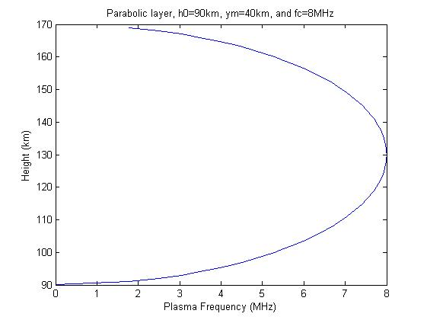

parabolic(10, 90, 8, 40, 105, 1)

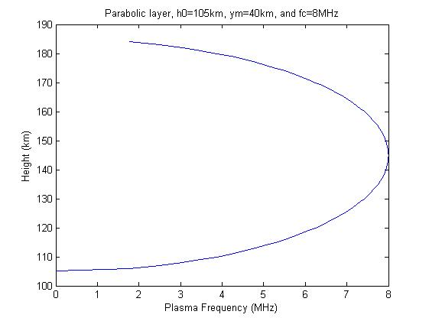

parabolic(10, 90, 18, 40, 105, 1)

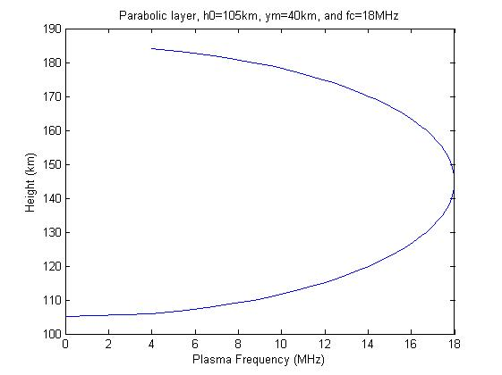

For D and E layers and different critical frequencies, the height of reflection increases when the ray frequency increases.

## Exercise NR1: Investigating the effect of changing elevation angle

Initializing the parameters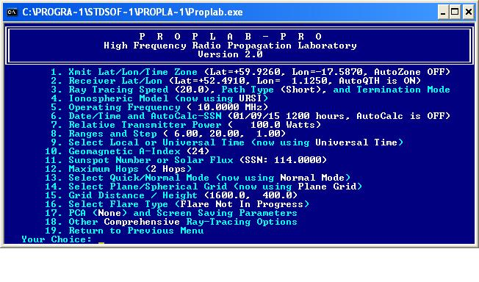

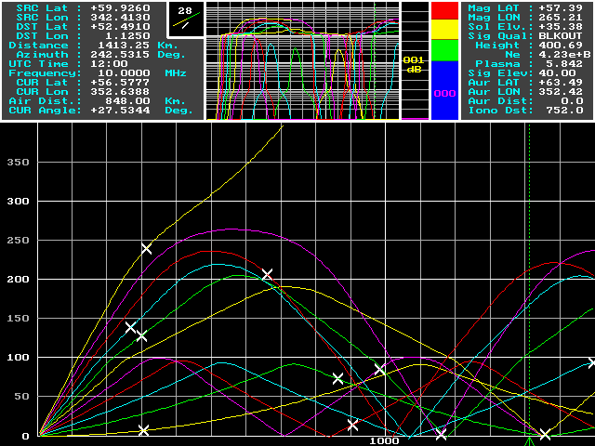

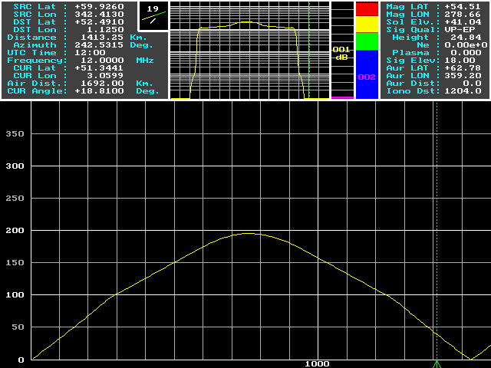

I find that the elevation angle 20° results in a ray landing which is nearest to the receiver.

Also the elevation angles 4° and 16° result in a ray landing near to the receiver.

The signal penetrates the E and F-regions at elevation angle 40°.

## Exercise NR2: Investigating the effect of changing the frequency

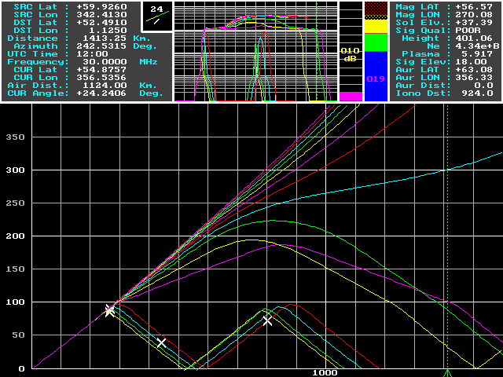

Rays land near to the receiver for the frequency 12MHz (marked as the middle yellow line).

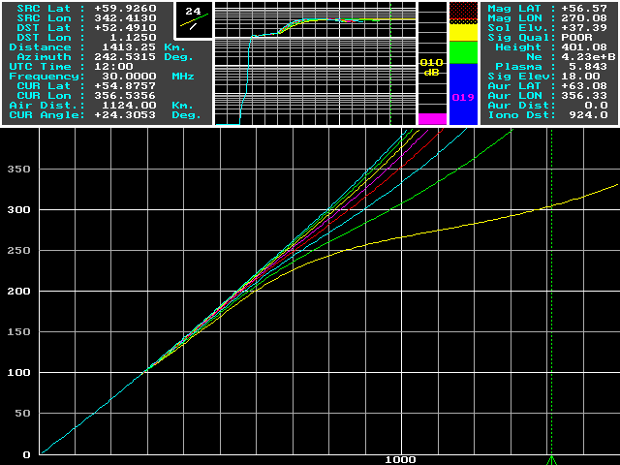

The signal penetrates the E and F-regions at 16MHz (marked as the lower yellow line)

## Exercise NR3: Investigating the influence of the time of day

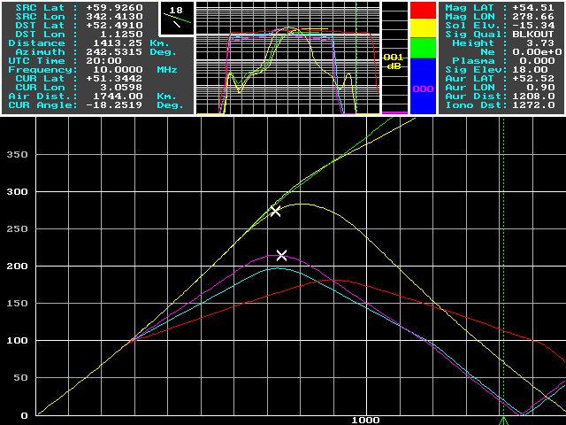

The signal penetrates the E and F-regions at first (0:00am and 4:00am) and then the signal is reflected to the ground (from 8:00am to 8:00pm).

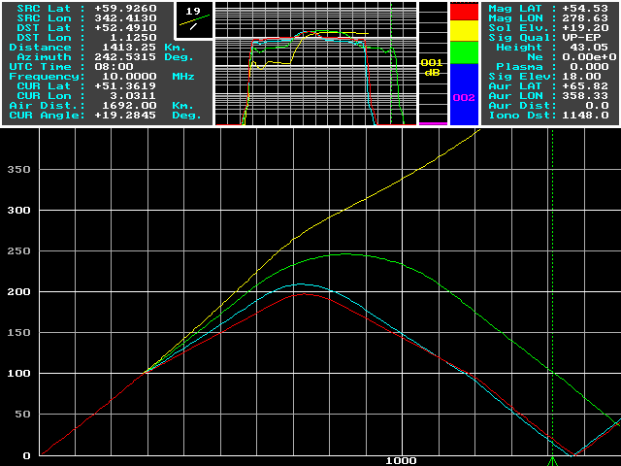

5:00am to 8:00am

We can see that the ray starts to be reflected from 6:00am. (Sunrise)

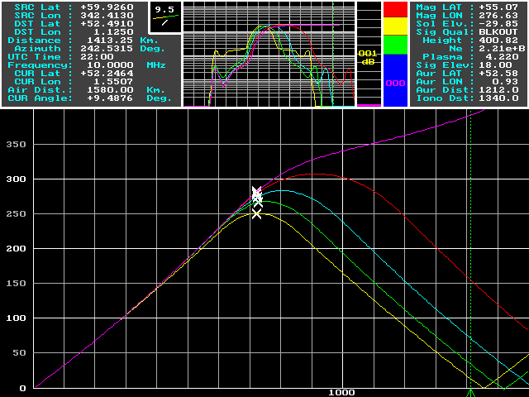

6:00pm to 10:00pm

We can see that the ray penetrates the E and F-regions at 10:00pm. (Sunset)

## Exercise NR4: Explaining the resultsC:\Documents and Settings\tony\Desktop\EG7023\SCREEN7.GIF

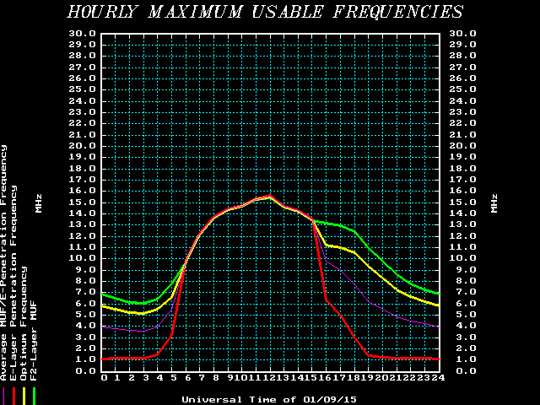

From the graph above, we can see that the penetration frequency is lower in the night time and higher in the day time. Thus, we use same frequency (10MHz) in the previous exercises; the signal penetrates before sunrise or after sunset.

## Exercise NR5: Creating an oblique ionogram

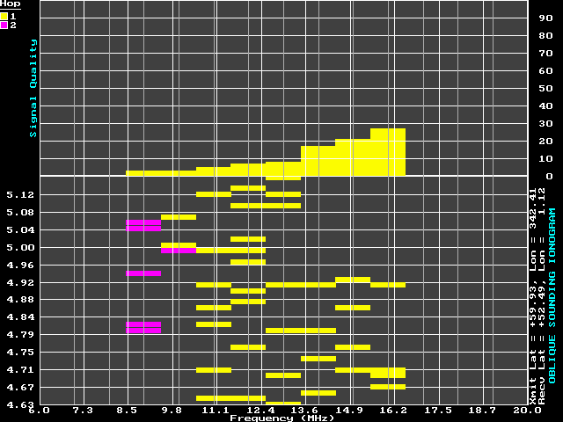

This is for midday.

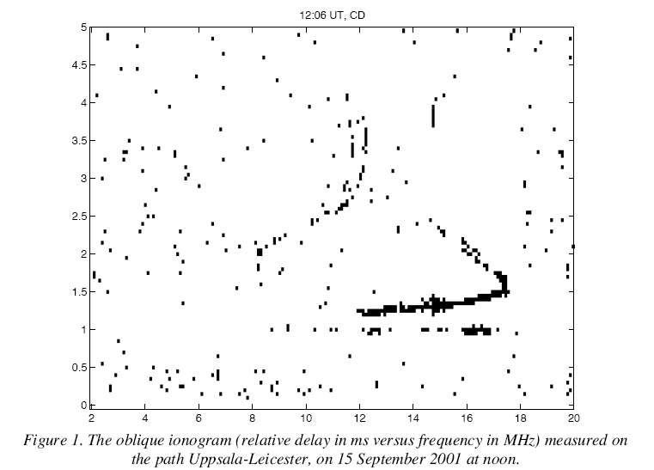

Through the oblique ionogram above, we can see that the first hops will appear between the range of frequency (8MHz-12MHz), and the second hops occur between 12MHz to 18MHz.The results of the simulated ionogram are similar to the oblique ionogram. However, the signal quality in the simulated version is poor, if I increase the resolution and the range that receiver gets the signal in to calculate again, the results will get better.

## Exercise NR6: Where can the signals be detected?

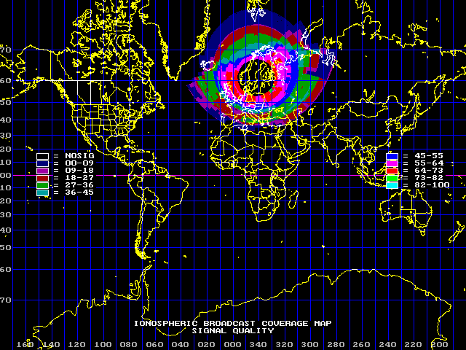

Each individual color is associated with a range of signal quality numerical values ranging from 0 (blackout, or no signal [NOSIG]) to 100, or extremely good signal quality. From the picture, we can see the signal quality is better when the location is closer to the transmitter, and is worse when the location is father. Especially, the signal will get worse due to the poloarization.

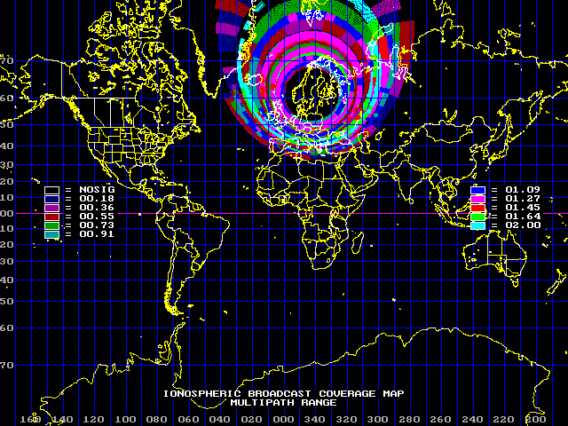

From the graph above, we can see that the multipath is denser when the latitude decreases and thinner when it is close to the polar region.

Then I try to use a directional antenna in the exercise.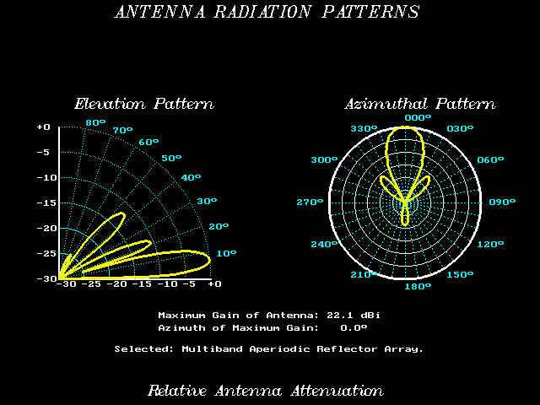

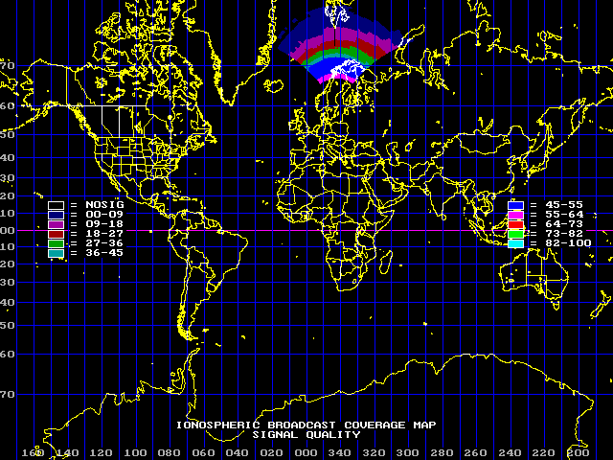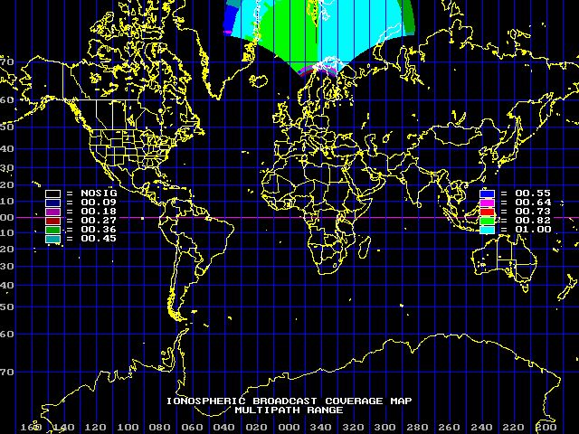

Comparing with the Isotropic Antenna, we can see the signal quality of directional antenna is better in the specific range of directions. And the Multipath range will also increase.

## Exercise NR7: Area coverage

Using the VOACAP, we can get the most suitable frequency and minimum transmitted power by comparing data for midday and midnight on September, 2001 with SSN=130

|  |  |  |
| --- | --- | --- |
| Location | Frequency(MHz) | Power(KW) |
| San Francisco | 11MHz | 40 |
| Athens | 9MHz | 4 |

The distance is longer, the bigger frequency and power will be required.

For Washington D.C., by using proplab, I use following parameters to get the graph of signal quality.

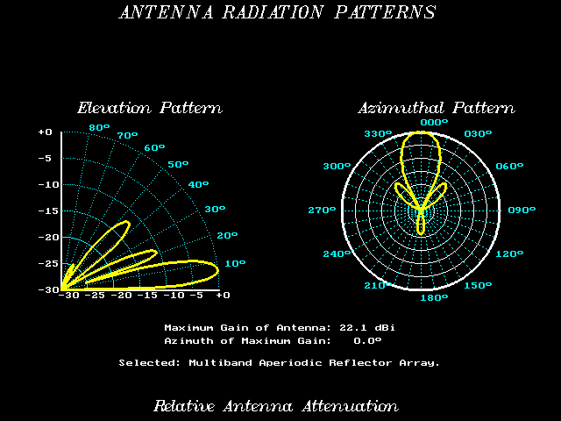

### Midday

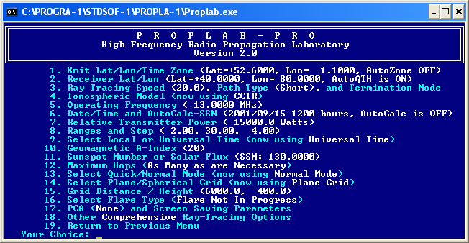

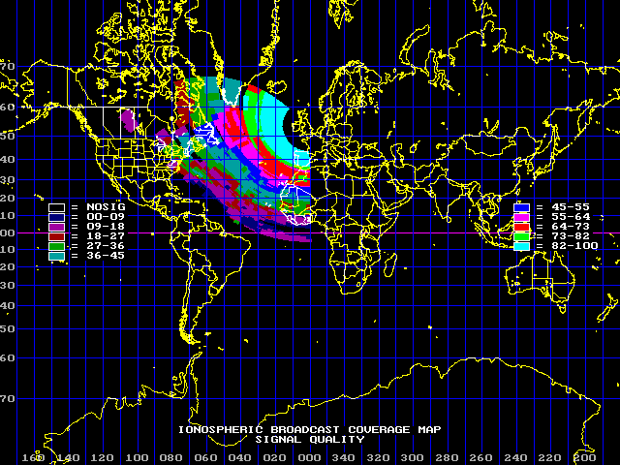

### Midnight

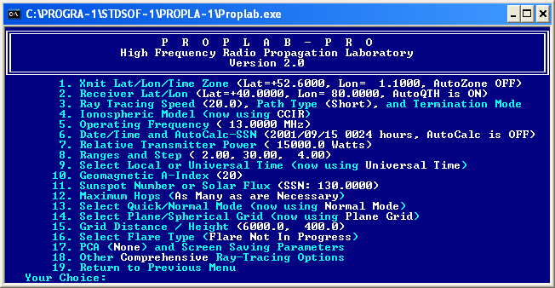

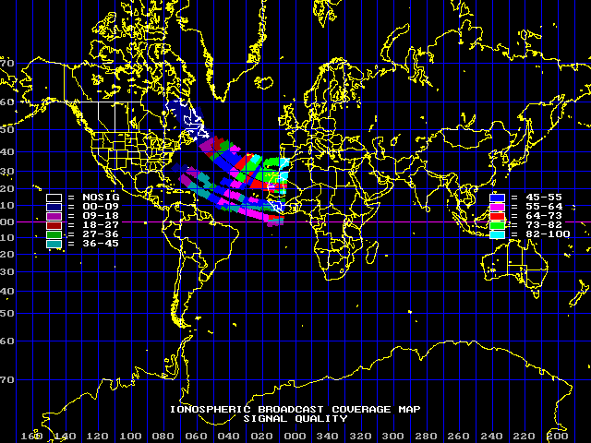

I use the similar parameters in the VOACAP program.

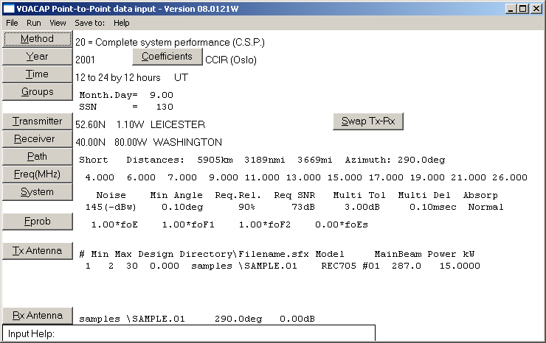

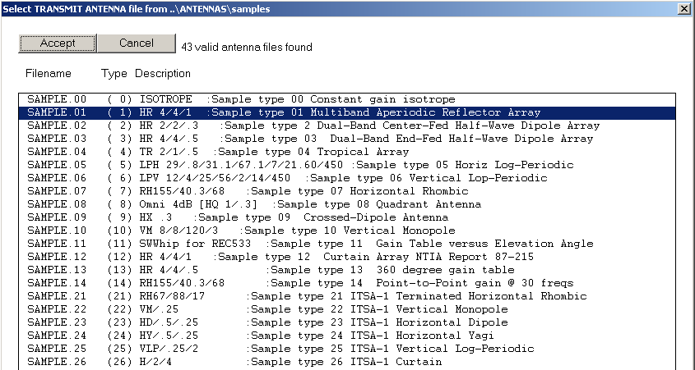

Get the result below:

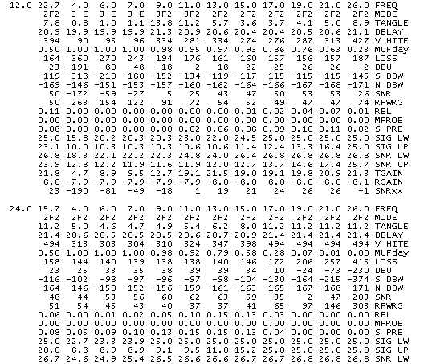

We can see that both programs show that the frequency 13MHz is not suitable and the power 15KW is also not enough. But It is difficult to see the differences between problab and VOACAP. Because the reliability in the VOACAP is relative with more parameters, and the graph generated by problab is about the signal quality which is not equal to the reliability. Moreover, VOACAP is the empirical method, and problab uses the physical theoretical model. Thus, there must be some differences between these two ways.

# Part Two

## VHF/UHF propagation

### Freespace.m

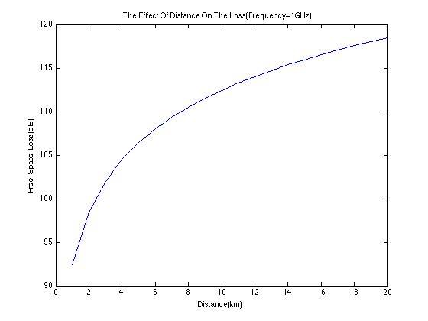

We can see that the free space loss will increase when the distance increases.

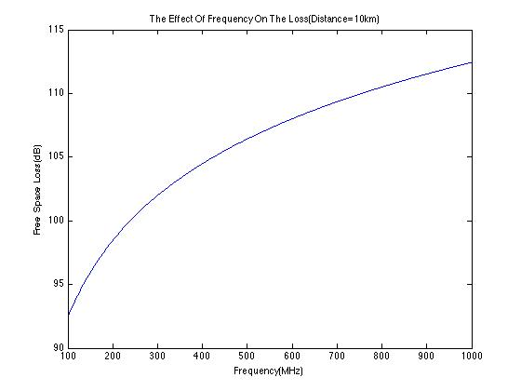

We can see that the free space loss will increase when frequency increases.

### Planereflec.m and planereflec2.m

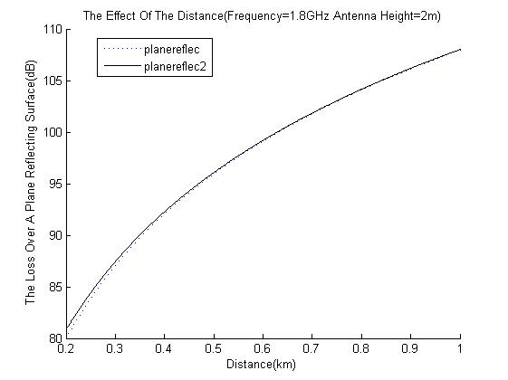

From the graph above, we can see that the loss over a range reflecting surface will increase when the distance increase, also the values from planereflec model are smaller than the planereflce2 when the distances are short.

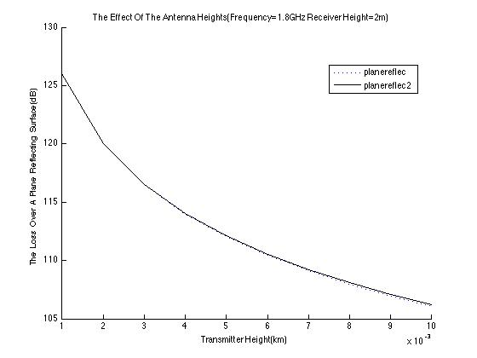

We can see that the loss will decrease when the transmitter height increases. And the values from planereflec are smaller than planereflec2 when the transmitter height is higher enough.

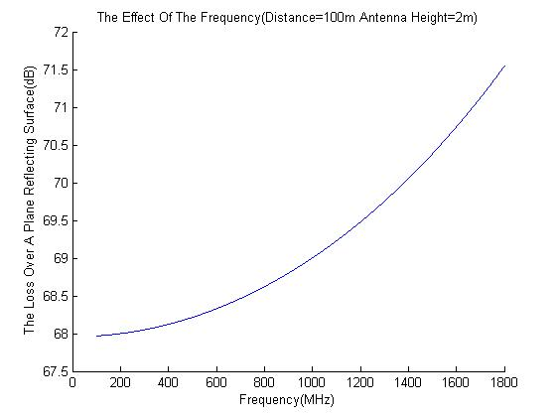

### Knifeedge.m

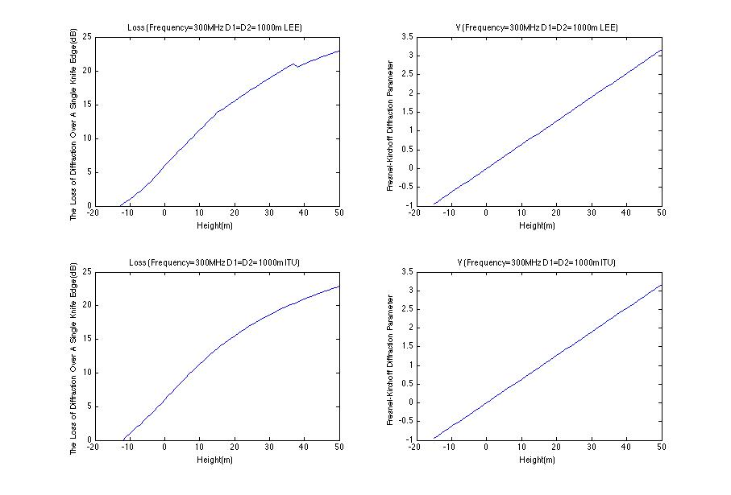

We can see that the loss data from both LEE and ITU models and v value will increase when the relative height increases.

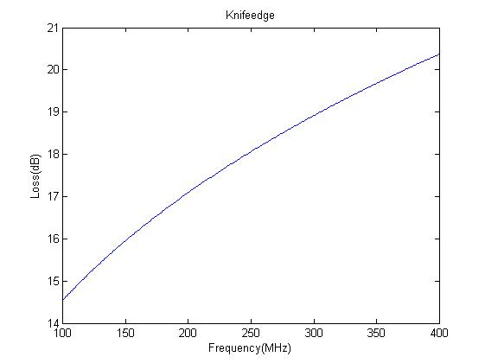

We can see that the loss will increase when frequency increases.

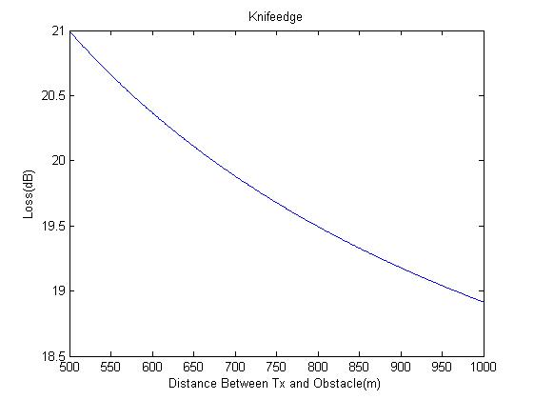

The loss will decrease when the distance between Tx and obstacle increases.

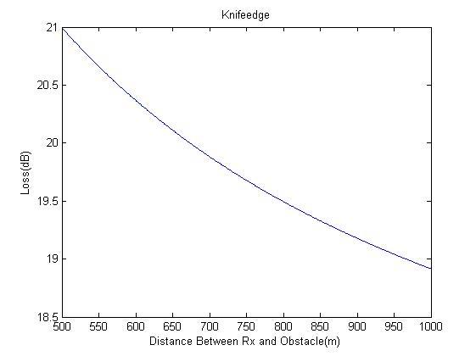

The loss will decrease when the distance between Rx and obstacle increases.

### epsteinP.m

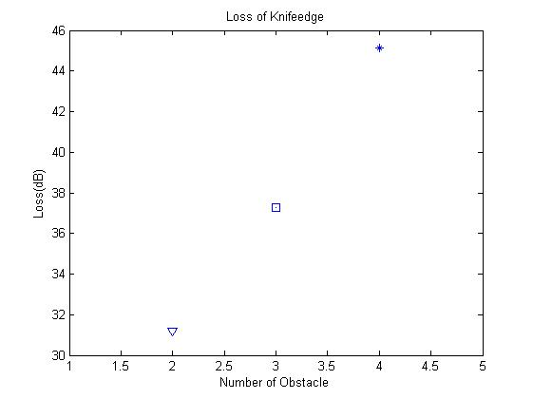

The loss will increase when the number of obstacle increases.

For different heights and spacing of obstacles, the situation of loss is similar to that in he knifeedge.m exercise.

### Vegetation.m

### C:\Documents and Settings\Tony\Desktop\EG4233\v1.jpg

The vegetation loss will increase when the frequency increase.

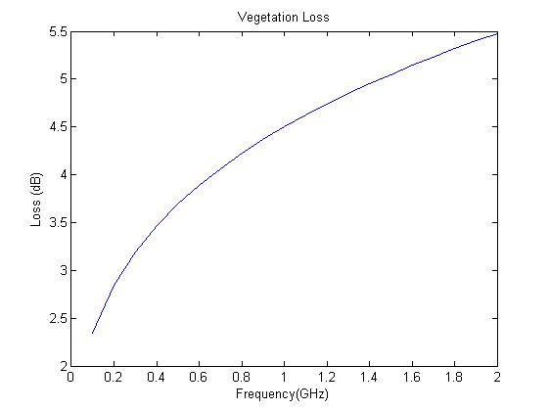

This is similar to the previous one, but trees are in leaf of this one.

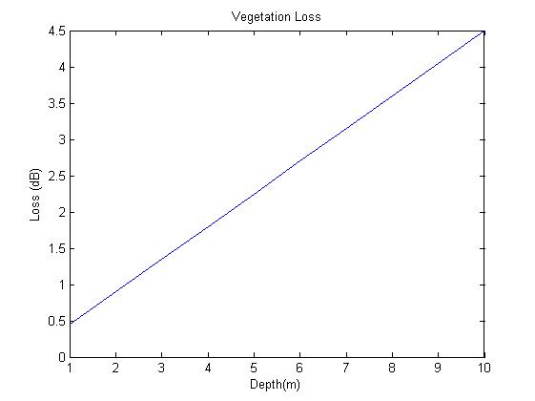

The loss will increase when the thickness of foliage increases.

### Hata.m

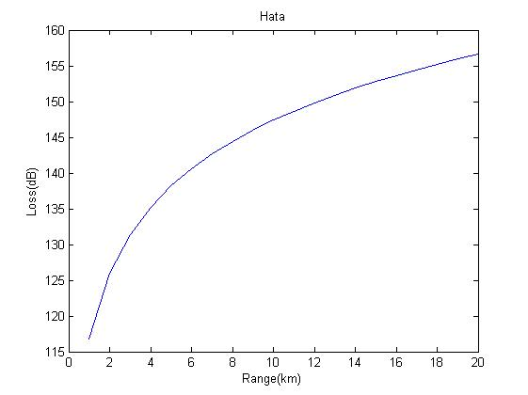

The loss will increase when distance between transmitter and receiver increases.

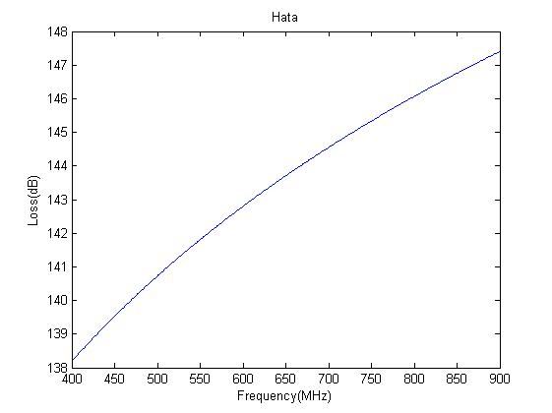

In hata model, the loss will increase when frequency increases.

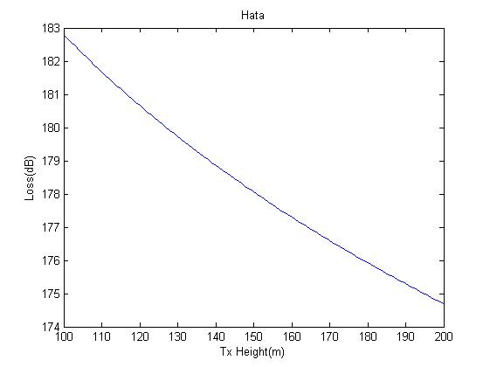

The loss will decrease when the transmitter height increases.

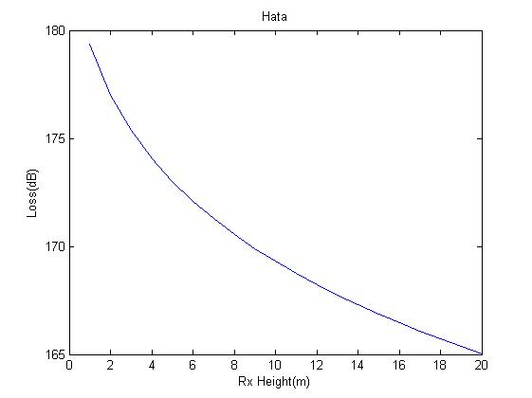

The loss will decrease when the receiver height increases.

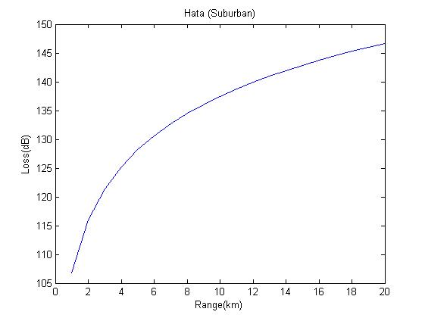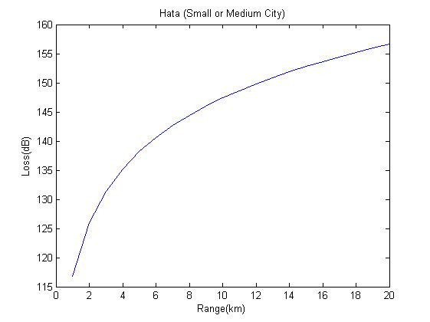

These two are in different land type, the shape is similar but the value of loss is bigger in small or medium city than in suburban area.

### Cost231hata.m

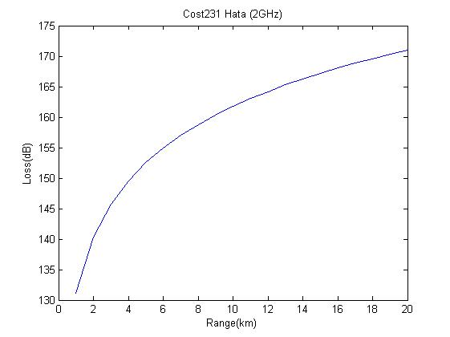



We can see the shape is similar but the value of loss is bigger in cost231hata model than that in hata model.

### cost231WalIke.m

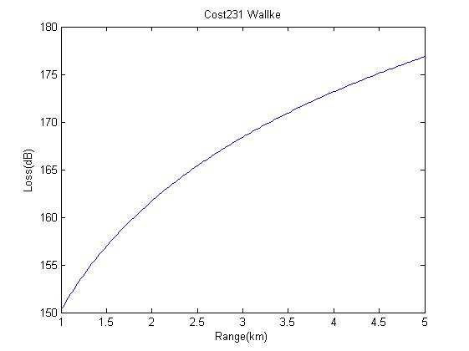

The loss will increase when the distance between transmitter and receiver increases.

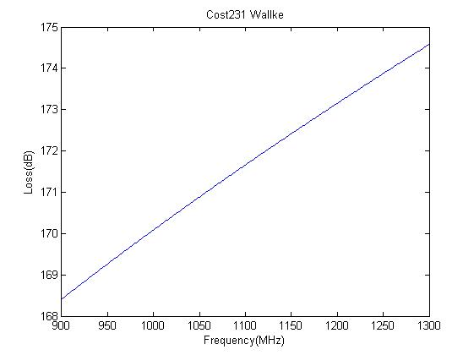

The loss will increase when frequency increases.

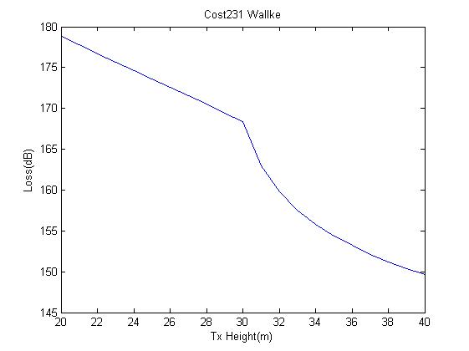

The loss will decrease when the transmitter height increases. In this case, the decrease rate of the loss reduces faster when transmitter height is higher than 30m.

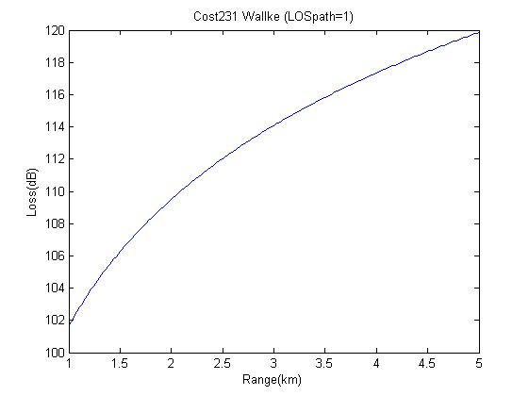

When LOSpath=1, The loss will increase when the distance between transmitter and receiver increases, but it is lower than that LOSpath=0.

### Coverage.m

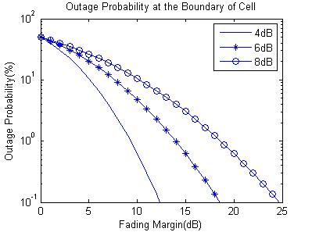

When the fading margin increases, the outage probability will decrease. For fixed fading margin, when the fading standard deviation increases, the outage probability will increase.

### Blocking.m

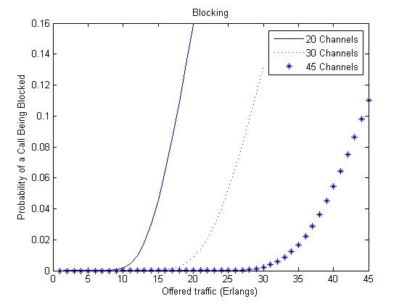

The probability of a call being blocked will increase when offered traffic increases. The more available channels can be used, the less probability. When the number of channel in the system increases, the probability of call blocking will decrease.

## Getting started – a first worked example using winprop

In the part, I will investigate the effect of one hill of the knife-edge diffraction.

## C:\Documents and Settings\Tony\Desktop\WP1\hill1.JPGC:\Documents and Settings\Tony\Desktop\WP1\Soft_turnover_plane_hill_res10_Ant 1.JPG

This is Okumura-Hata model (dense urban areas)

## C:\Documents and Settings\Tony\Desktop\WP1\Soft_turnover_plane_hill_res10_Ant 2.JPG

This is Okumura-Hata model (open area)

Through the two graphs above, we can see that the power of the signal loss a lot due to the knife-edge diffraction by the hill. Also, in the open area, the lost power is smaller than that in the dense urban areas.

Through graph below we can see that the power drops fast suddenly at the distance 400m.This distance should be the distance between transmitter and hill.

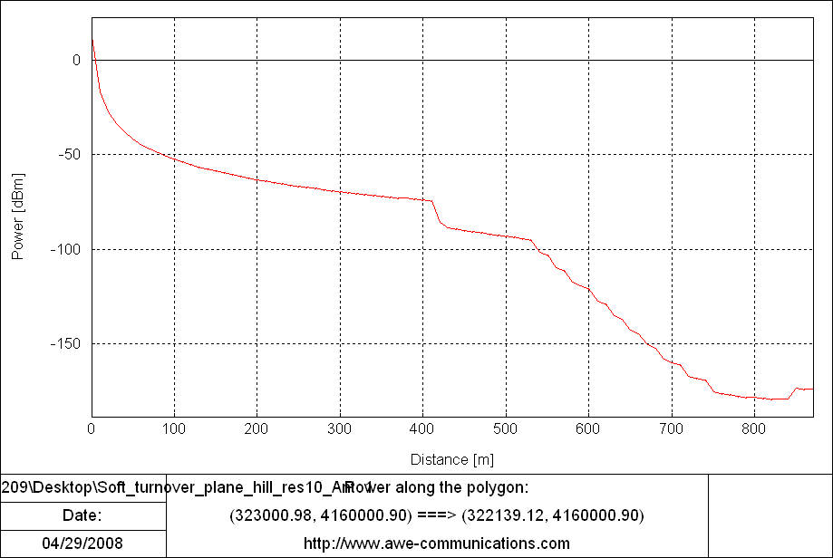

## Exercise WP1: Changing the loss model

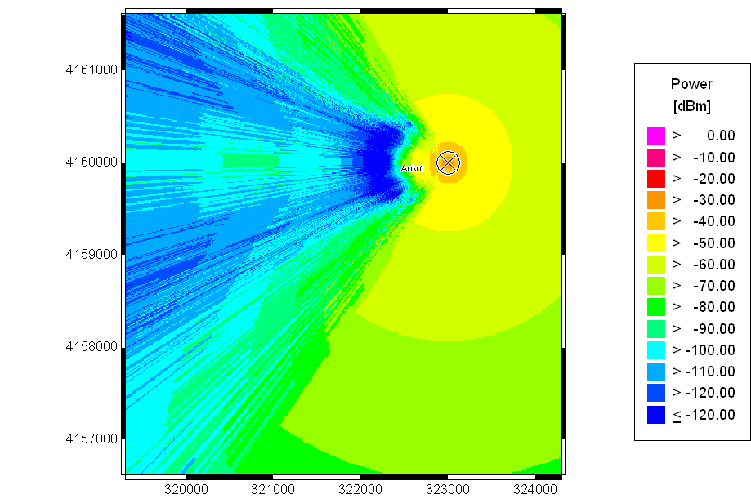

This model is empirical two ray model, we can see that the power loss condition is better than the Okumura-Hata model.

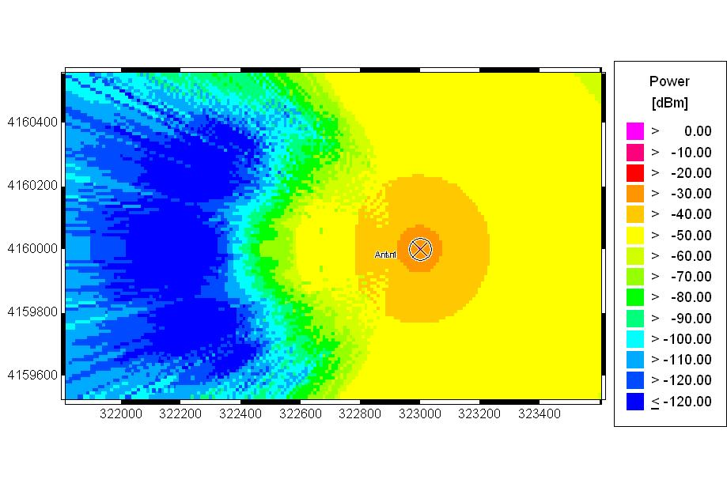

Empirical two ray model

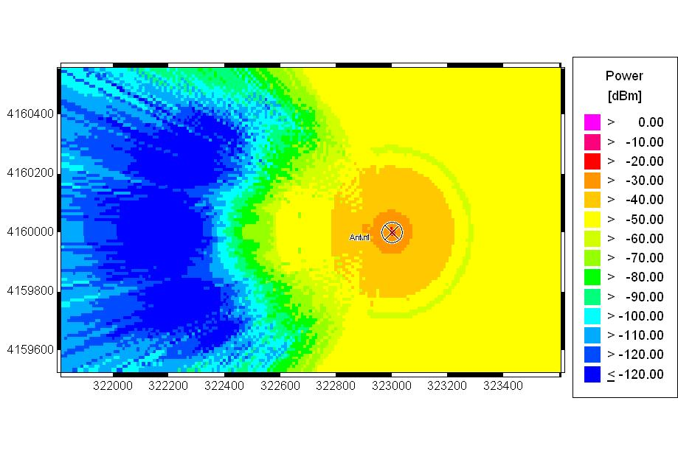

Deterministic two ray model

From the two graphs above, we can see that there is more power in deterministic two ray model than that in the empirical version of the model at the locations close to the transmitter.

## Exercise WP2: The effect of two hills

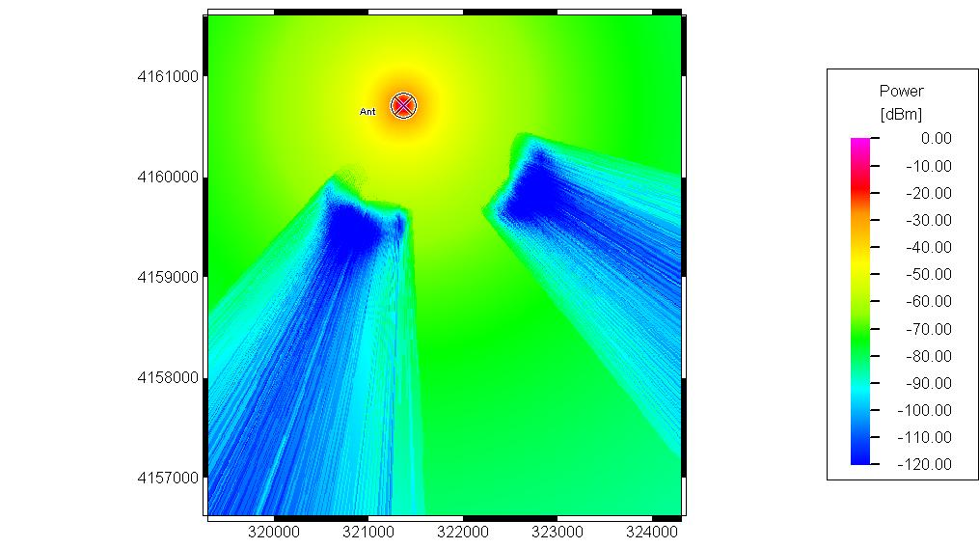

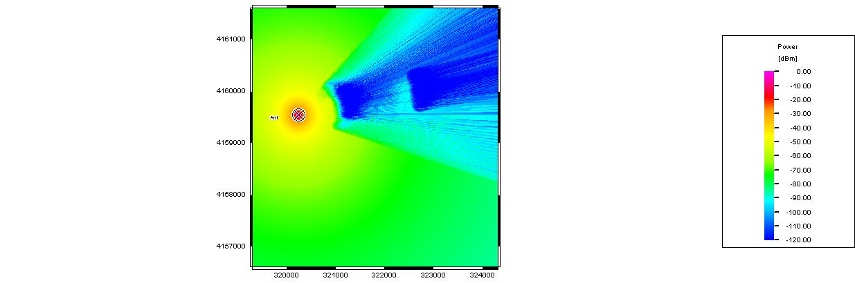

Through the graphs above, we can see that the situations here are similar than that with one hill. It just has two diffractions over the two hills.

## Exercise WP3: More realistic terrain

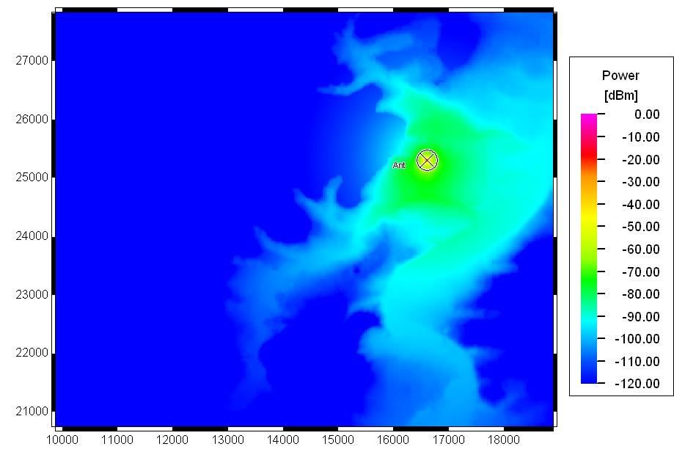

Base station height=1.5m power=10w

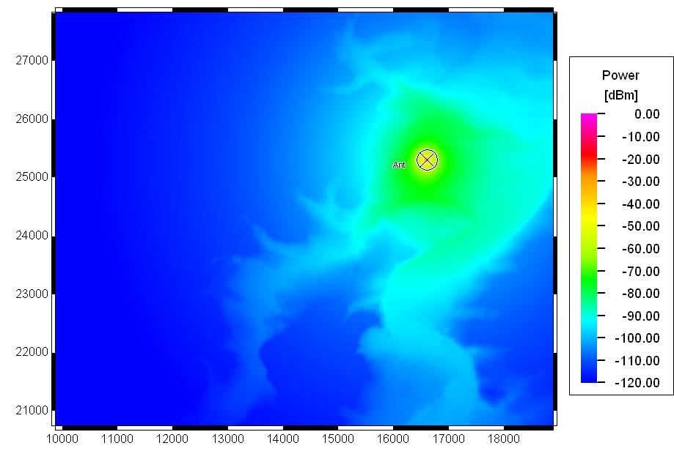

Base station height=15m power=10w

We can see that the signal quality gets better when the base station height increases.

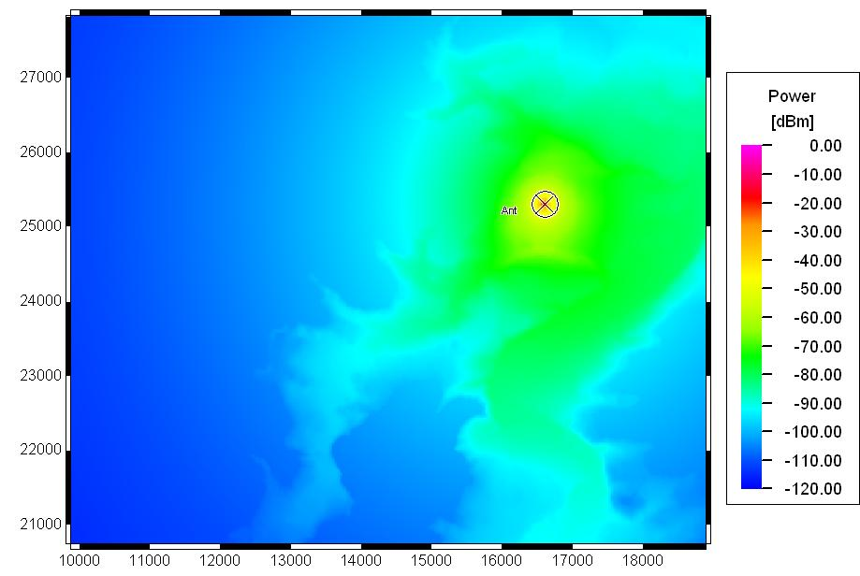

Base station height=15m power=100w

We can see that the signal quality gets better when power increases.

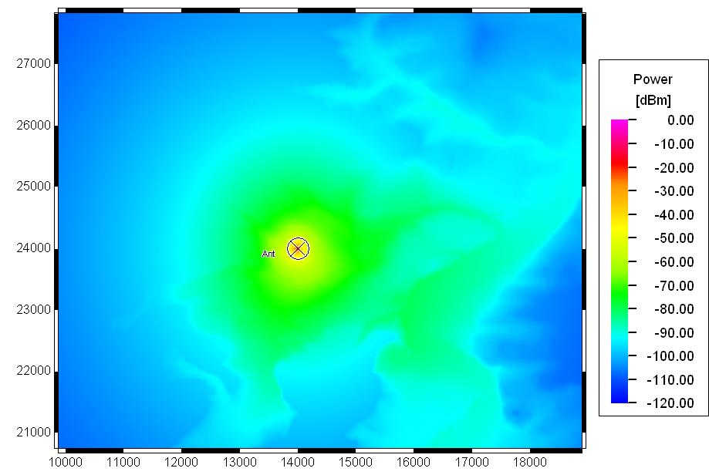

Base station height=15m power=100w

In this picture, I just change the location of the base station. Due to the different type of landscape, the power distribution is different comparing with the previous one.

## Example: A first Network Planning Project

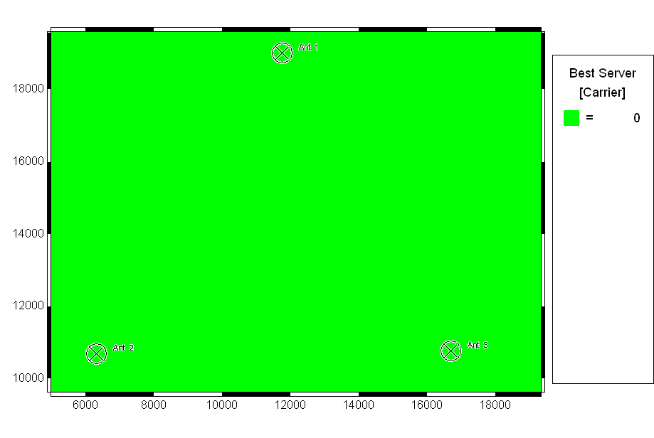

Best Server

Because the three antennas use same channel, the best server should only be the channel 0.

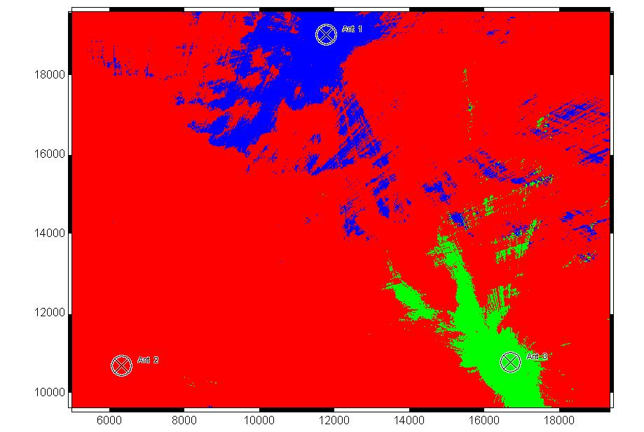

Cell Area

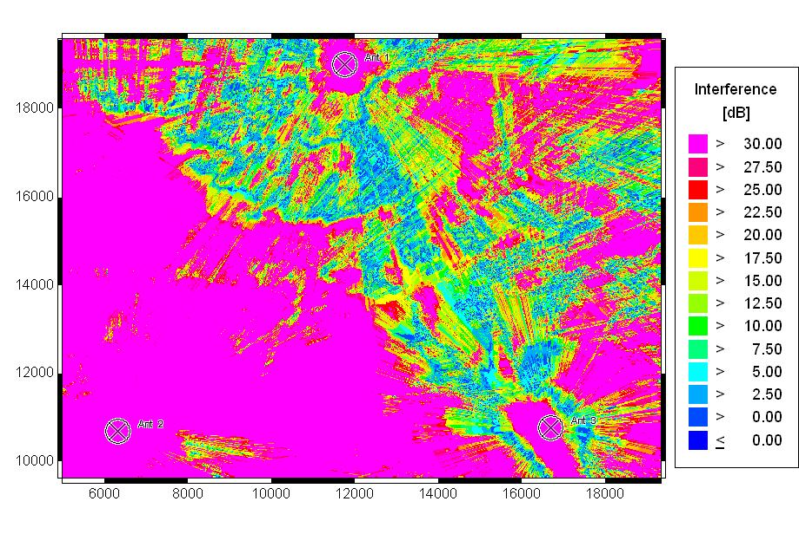

CoChannel Interference

Because three antennas use same channel, the cochannel interference are very poor.

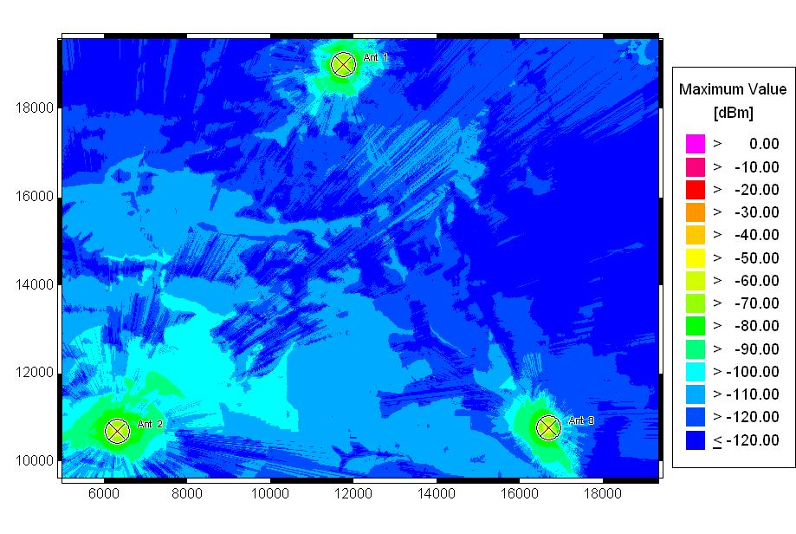

Maximum Power

This graph shows the maximum power of each pixel. The power is higher when it is closer to the base station.

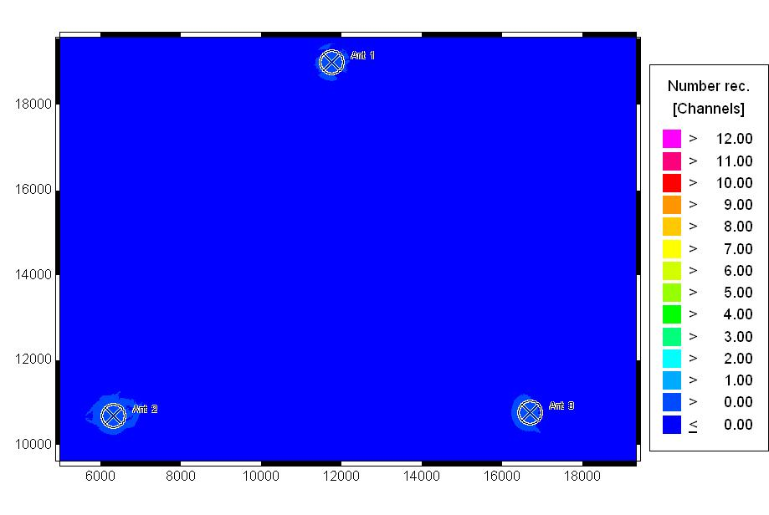

Nr Received Channels

## Exercise WP4: Optimizing the network

In this exercise, I change the location of the antennas, number of channel and the height of antenna.

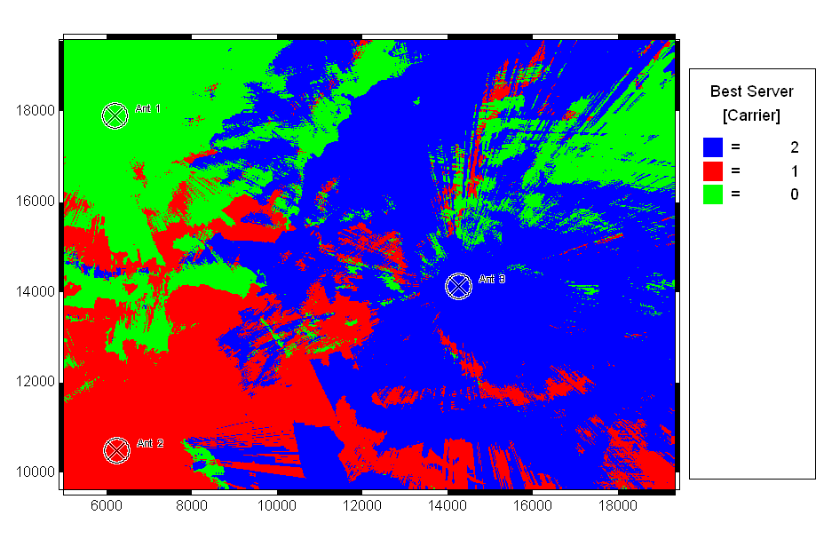

Best Server

The picture shows the best frequency for every pixel. And it is more likely the channel best for the pixel is same as the channel used by antenna.

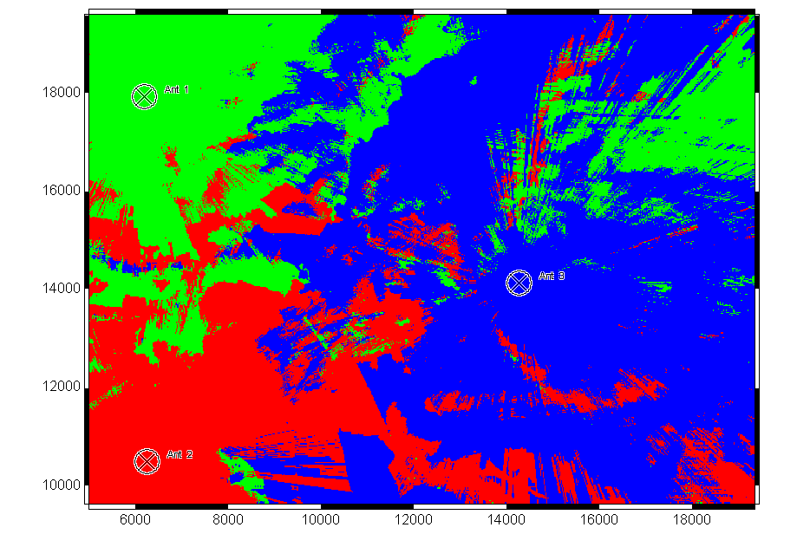

Cell Area

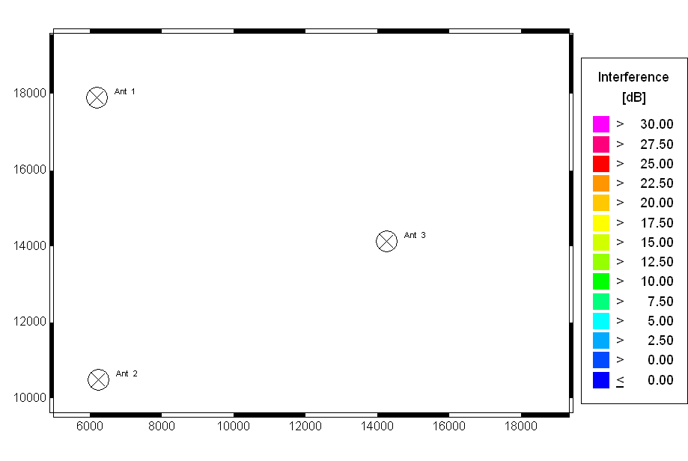

CoChannel Interference

Because we use different channels for the three antennas, there will be no cochannel interference.

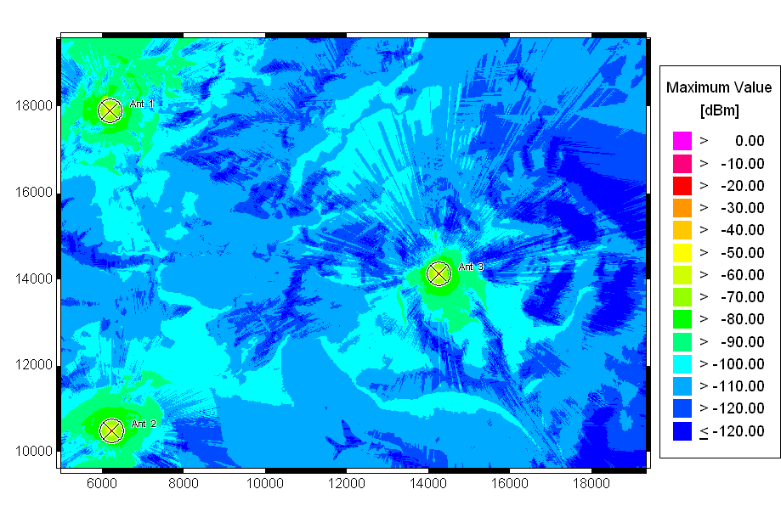

Maximum Power

After we change the location of the antennas, we can see the power distribution is getting better than the previous one.

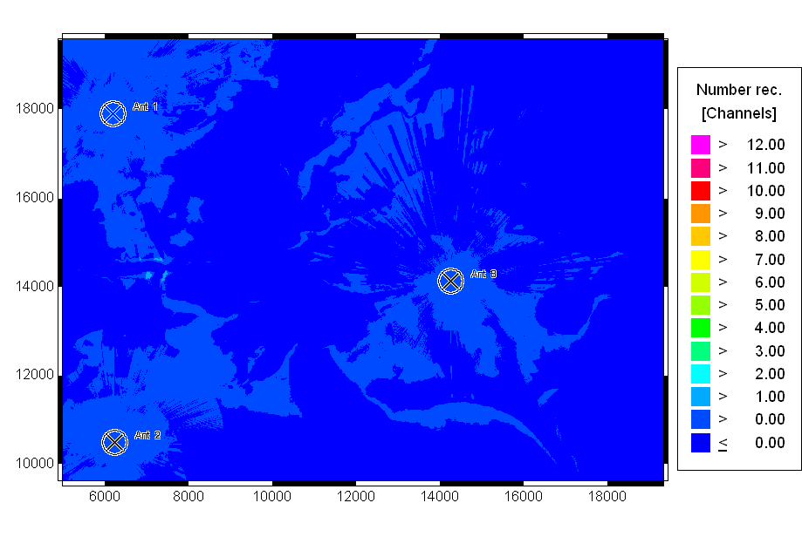

Nr Received Channels

The number of received channels for each pixel also gets better.

## Example: An Urban Project

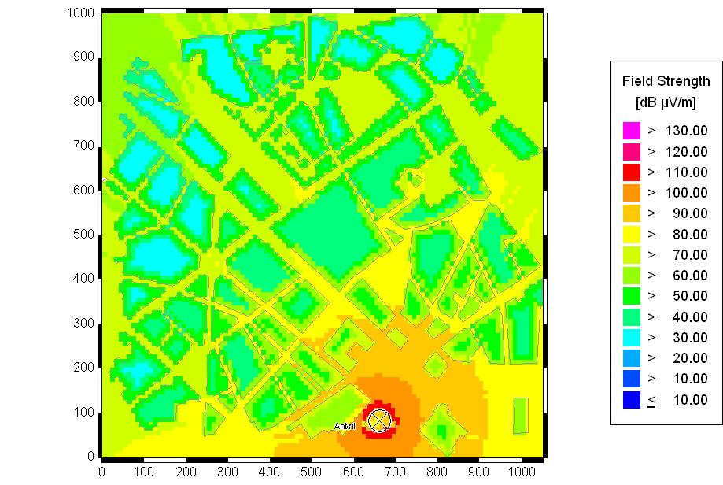

After put the antenna on the roof of tallest building, the signal power is better when it is closer to the base station and the outdoor reception is better than indoor’s.

## Exercise WP5: Using directional antenna

In this exercise, I use directional antenna instead of the isotropic one.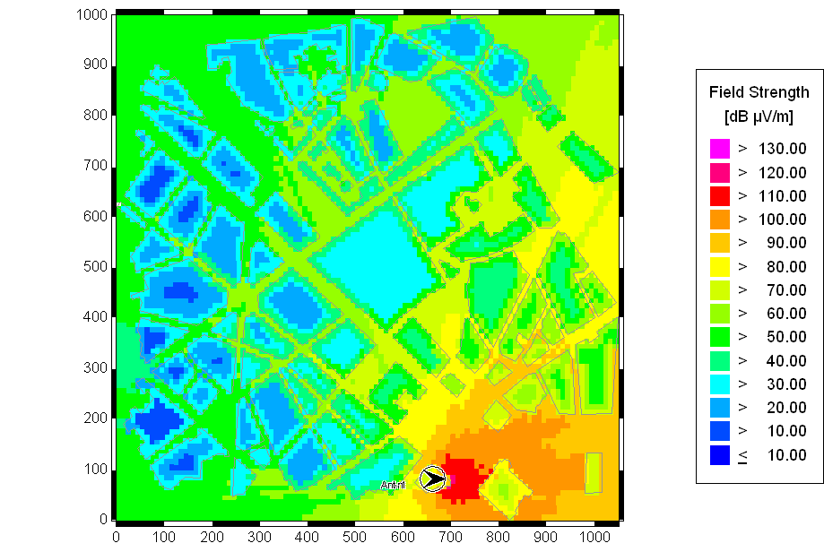

Azimuth=0˚ Downslope=0˚

We can see that the location is on the direction of the antenna, the signal will better, otherwise, the signal quality is poor.

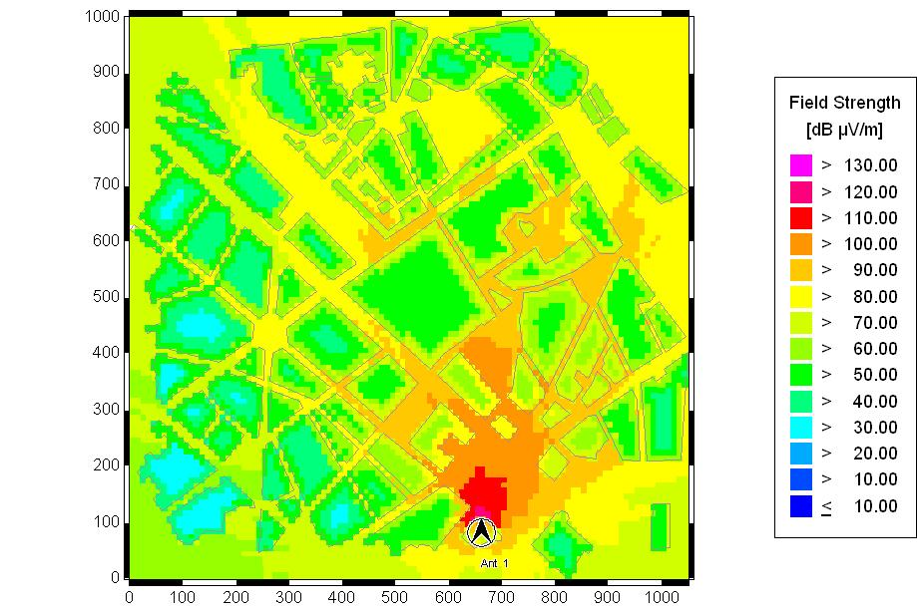

Azimuth=90˚ Downslope=0˚

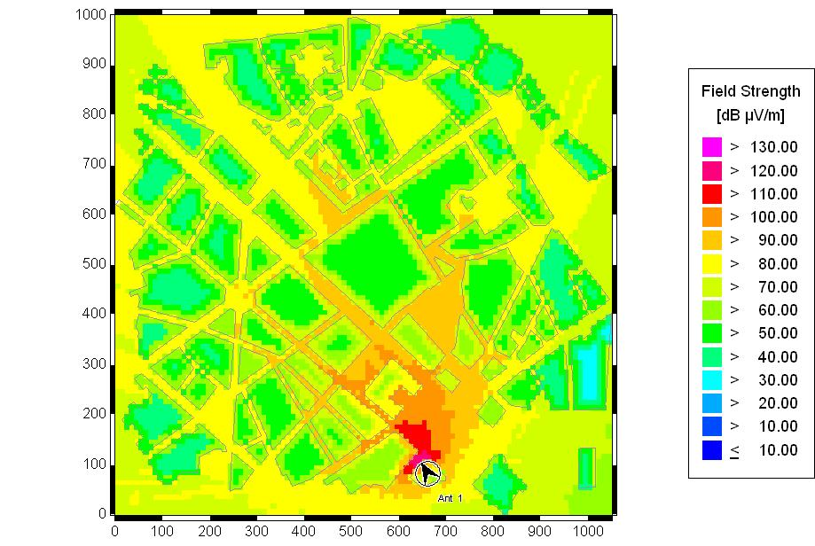

Azimuth=120˚ Downslope=0˚

Through the two pictures above, we can see the best azimuth is 120˚.

Then I try to change the downslope to investigate the effect to the power distribution.

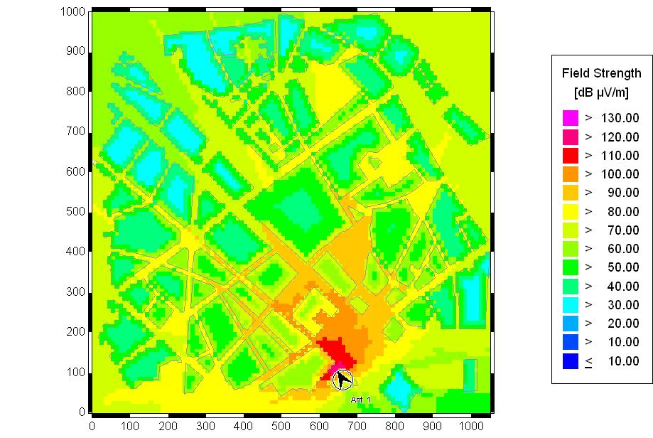

Azimuth=120˚ Downslope=20˚

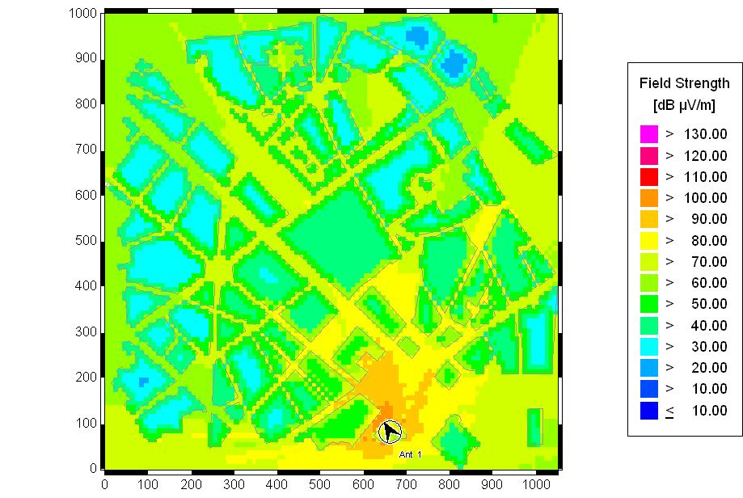

Azimuth=120˚ Downslope=-20˚

So when we put the antenna face the ground a little, the signal power will be better near the station and worse far from station. When we put the antenna face the sky a little, the signal power gets worse for all the location.